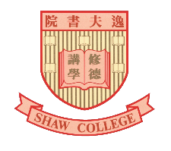
Shaw College
General Education Programme
Shaw Gatherings
Application Form
***********************************************************************************************
Shaw Gatherings are part of the non-formal education activities under college general education programme. They are held to facilitate the appreciation of different art forms and cultures by students and staff. They also provide opportunities for talented students of Shaw College to perform. Shaw Gatherings are held during term time, usually during lunch hours of Fridays.
Notes: | - The applicant must be student of Shaw College.  - Please email the completed application form along with past performance videos or photos (if any) to zoelam@cuhk.edu.hk by 19 February, 2023. The college will proactively contact eligible applicants to arrange performances.  - The college reserves the right to make the final decision regarding performance arrangements and other details.
***********************************************************************************************
Chinese Name: |  | English Name:
Student ID: |  | Major: |  | Year:
CUHK E-mail: |  | Contact No.:
Performance items:
Affiliated unit (if any): |  | Number of performers:
(e.g. Shaw Drama Club)
Performance introduction:
Budget:  (The College will provide no more than HK$1,500 to support students in preparing performance materials.) | Materials | Amount (HKD)
 | To:

***********************************************************************************************
Performer list
 | Name | Student ID (if applicable) | Shaw Student | CUHK Student | Non-CUHK Student
1  (Contact Person) |  |  | ✓ | ✓
2
3
4
5
6
7
8
9
10

***********************************************************************************************
I / We* agree to comply with all terms, regulations and important notes of “Shaw Gatherings”, and accept that Shaw College reserves the right to change the terms, regulations and important notes of the Scheme.

Signature of Contact Person: |  |  | Date：

